The Focusing Question

What is the One Thing I can do such that by doing it everything else is easier or unnecessary?

The Top Practices Goal Worksheets are divided into these categories: Personal, Career, Financial, Health and Fun. Using the focusing question how can you accomplish your goals in these areas?

The Top Practices Goal Worksheets are also set up so that you can work backwards from your Lifetime Goal to the current 12 Week period that you are in. You must be able to draw a straight line from your 12 Week Goal to your Three-Year Vision to your Lifetime Goal.

You've got to do these goals in all the important areas of your life, because you must discover your purpose. What is it that you truly and deeply care about that gives your life purpose and meaning? Your ONE THING—building your practice to its best possible outcome is not your purpose. It will not sustain you in the difficult moments. It must be something deeply personal that you care about. It's what gives your life meaning and purpose. THIS exercise is how you find your "WHAT?" What am I doing all of this for? If you don't have this, then keeping focused on YOUR ONE THING will be very difficult. The following goal worksheets are designed to help you discover your purpose. Take this very seriously or risk failing.

Copyright ©2015 Top Practices, LLC. All rights reserved. TopPractices.com Page 6

WRITING GOALS

Mindset Number ONE: The true purpose of your practice or career is to serve YOU and to fund your IDEAL LIFESTYLE – not the other way around. YOU MUST BEGIN BY PUTTING YOUR PERSONAL LIFE FIRST AND GETTING YOUR PRACTICE PRIORITIZED CORRECTLY.

Mindset Number TWO: A goal not reduced to writing and reviewed often is a

MERE WISH.

The goals you ultimately create must be S.M.A.R.T.

Specific – A specific goal has a much greater chance of being accomplished than a general goal. To set a specific goal you must answer the six "W" questions:

• Who:

• What:

Who is involved?

What do I want to accomplish?

- Where: Identify a location.

- When: Establish a time frame.

- Which: Identify requirements and constraints.

• Why: Specific reasons, purpose or benefits of accomplishing the goal.

EXAMPLE: A general goal would be, "Get in shape." But a specific goal would say, "Join a health club and workout 3 days a week."

Measurable – Establish concrete criteria for measuring progress toward the attainment of each goal you set. When you measure your progress, you stay on track, reach your target dates, and experience the exhilaration of achievement that spurs you on to continued effort required to reach your goal.

To determine if your goal is measurable, ask questions such as......How much?

How many? How will I know when it is accomplished?

Copyright ©2015 Top Practices, LLC. All rights reserved. TopPractices.com Page 7

Attainable – When you identify goals that are most important to you, you begin to figure out ways you can make them come true. You develop the attitudes, abilities, skills, and financial capacity to reach them. You begin seeing previously overlooked opportunities to bring yourself closer to the achievement of your goals.

You can attain most any goal you set when you plan your steps wisely and establish a time frame that allows you to carry out those steps. Goals that may have seemed far away and out of reach eventually move closer and become attainable, not because your goals shrink, but because you grow and expand to match them. When you list your goals, you build your self-image. You see yourself as worthy of these goals, and develop the traits and personality that allow you to possess them.

Realistic – To be realistic a goal must represent an objective toward which you are both willing and able to work. A goal can be both high and realistic; you are the only one who can decide just how high your goal should be. But be sure that every goal represents substantial progress. A high goal is frequently easier to reach than a low one because a low goal exerts low motivational force. Some of the hardest jobs you ever accomplished actually seem easy simply because they were a labor of love.

Your goal is probably realistic if you truly believe that it can be accomplished. Additional ways to know if your goal is realistic is to determine if you have accomplished anything similar in the past or ask yourself what conditions would have to exist to accomplish this goal.

Time Bound – A goal should be grounded within a time frame. With no time frame tied to it there's no sense of urgency. If you want to lose 10 lbs., when do you want to lose it by? "Someday" won't work. But if you anchor it within a timeframe, "by May 1st", then you've set your unconscious mind into motion to begin working on the goal.

Copyright ©2015 Top Practices, LLC. All rights reserved. TopPractices.com Page 8

Writing your GOALS

What are your goals?

Lifetime Three-Year Vision Next 12 Weeks

Personal/Career/Financial/Health/Fun

It’s time to write out your goals for your Personal Life, and Career, Your Financial Goals, Your Health Goals, and Your Fun Goals. In each section, write your Lifetime Goals, Your Three-Year Vision, and Your Plan for the Next 12 Weeks.

Your Lifetime Goals

Start with your Lifetime Goal. Gary Keller calls this your someday goal, in the 12 Week Year Brian Moran calls it your aspirational Vision. It’s essential that you take the time to think through what you truly desire with a “burning desire.” Sometimes those goals can be elusive at first. Do not let this deter you. Sometimes the goals you write in this section are your “best shot” at stating what you want. That is fine. These goals are to be written “in pencil.” Which means that we can change or adjust them as they either become clearer or are achieved and need to be revised to something much higher. No matter what, persevere and as you put your dreaming hat on you will find what you desire begins to come into focus. Sometimes your goals are already crystal clear. Always ask yourself if they are big enough, daring enough, fulfilling enough. It is important to have goals that inspire you so much that you can use them to get you through the challenges and roadblocks you will inevitably face.

This form has room for 5 Lifetime goals. If you have more then add them. If you have less than only write those. Three to Seven Great Lifetime goals is most common. Even though these are lifetime goals you must put time frames on them. If you don’t know the correct time frame take your best guess, but time bound goals are essential.

Copyright ©2015 Top Practices, LLC. All rights reserved. TopPractices.com Page 9

Your Three-Year Vision

Next you need to write your vision of where you need to be in three years from today in order to be on your path to achieving your lifetime goals. All of your 3

year goals must be connected to a lifetime goal. If they aren’t you need to review your lifetime goals. Did you miss one? If not, then the goal you’ve just written may not be a goal. You can’t work on three year goals that don’t

support ultimate goals. These become much more specific and focused and should reflect that in their writing.

Your 12 Week Goals

This is the part of goal work that involves serious, focused and intense execution.

Read “The 12 Week Year” by Brian Moran for an excellent discussion of executing in 12 week periods. In this section, you make serious plans for achieving important milestones for your goals in the next 12 weeks.

This is a working document. You can use it in two ways. To focus you in the five areas of your life and to get things done much more quickly and effectively. So, you should have 12 week goals in each area of your life. If you want to lose weight, you need goals and a plan. If you want to be achieving your financial goals you need goals and a plan for saving and investing. If you want to improve your marriage or your relationship with a child you need goals and a plan to achieve it. If you want your practice to grow and prosper you need a marketing and management plan.

Therefore, you DO NEED to get super specific and think this through now, BUT in truth you can’t do everything at once. At the outset of this program we discussed the Top Three Goals you must be focusing on in the next 12 weeks. When you complete these goals –and it will take some real action to do this –you need to check the Top Three Goals you’ve already described and make some decisions. Are these the right top three goals? If not –then change them based on the real work you’ve just completed. Then for the next 12 weeks hyper focus on these goals and make some real progress. At the end of that 12-week period, take one week off and then attack your next three goals in the next 12-week period. By doing this you will begin to accomplish more than you ever have in the past.

Copyright ©2015 Top Practices, LLC. All rights reserved. TopPractices.com Page 10

It is important now to point out that if you want to lose weight, you can’t wait until that goal finally comes up to the top three. You’ve got to be working that plan every single day, however you could take the summer for instance and raise your health goal to the very top of the list and achieve more in 12 weeks than you ever have before and in the fall, attack your marketing with renewed vigor and health. Get the picture? This is something you must commit to and review every day if you want to finally live that successful life that you and all of us so desire.

A note about Personal Goals. This is the one area people struggle with the most – what is this? It can include your spiritual goals, your relationships, your homes, college for your children etc. These are goals that do not fall into the other main areas.

A note about Fun Goals. This is the one area everyone wants to skip because they think it isn’t important. Nothing could be further from the truth! Without your fun goals –vacations, classes for piloting an airplane, painting, putting –it doesn’t matter what –without these goals life is pretty mundane and routine. At the end of your life you will not remember many of these goals that are so important today, but you will remember and cherish all of the fun goals.

Copyright ©2015 Top Practices, LLC. All rights reserved. TopPractices.com Page 11

My Personal Goals Are:

Lifetime Goals and Visions

1.

2.

3.

4.

5.

Three-Year Vision for each goal

1.

2.

3.

4.

5.

My 12 Week Plan for my personal Goals. (You might be focusing on only one in this 12-week period or none depending on your focus.)

1.

2.

3.

4.

5.

Copyright ©2015 Top Practices, LLC. All rights reserved. TopPractices.com Page 12

My Career Goals Are:

Lifetime Goals and Visions

1.

2.

3.

4.

5.

Three-Year Vision for each goal

1.

2.

3.

4.

5.

My 12 Week Plan for my personal Goals. (You might be focusing on only one in this 12-week period or none depending on your focus.)

1.

2.

3.

4.

5.

Copyright ©2015 Top Practices, LLC. All rights reserved. TopPractices.com Page 13

My Financial Goals Are:

Lifetime Goals and Visions

1.

2.

3.

4.

5.

Three-Year Vision for each goal

1.

2.

3.

4.

5.

My 12 Week Plan for my personal Goals. (You might be focusing on only one in this 12-week period or none depending on your focus.)

1.

2.

3.

4.

5.

Copyright ©2015 Top Practices, LLC. All rights reserved. TopPractices.com Page 14

My Health Goals Are:

Lifetime Goals and Visions

1.

2.

3.

4.

5.

Three-Year Vision for each goal

1.

2.

3.

4.

5.

My 12 Week Plan for my personal Goals. (You might be focusing on only one in this 12 week period or none depending on your focus.)

1.

2.

3.

4.

5.

Copyright ©2015 Top Practices, LLC. All rights reserved. TopPractices.com Page 15

My Fun Goals Are:

Lifetime Goals and Visions

1.

2.

3.

4.

5.

Three-Year Vision for each goal

1.

2.

3.

4.

5.

My 12 Week Plan for my personal Goals. (You might be focusing on only one in this 12 week period or none depending on your focus.)

1.

2.

3.

4.

5.

Copyright ©2015 Top Practices, LLC. All rights reserved. TopPractices.com Page 16

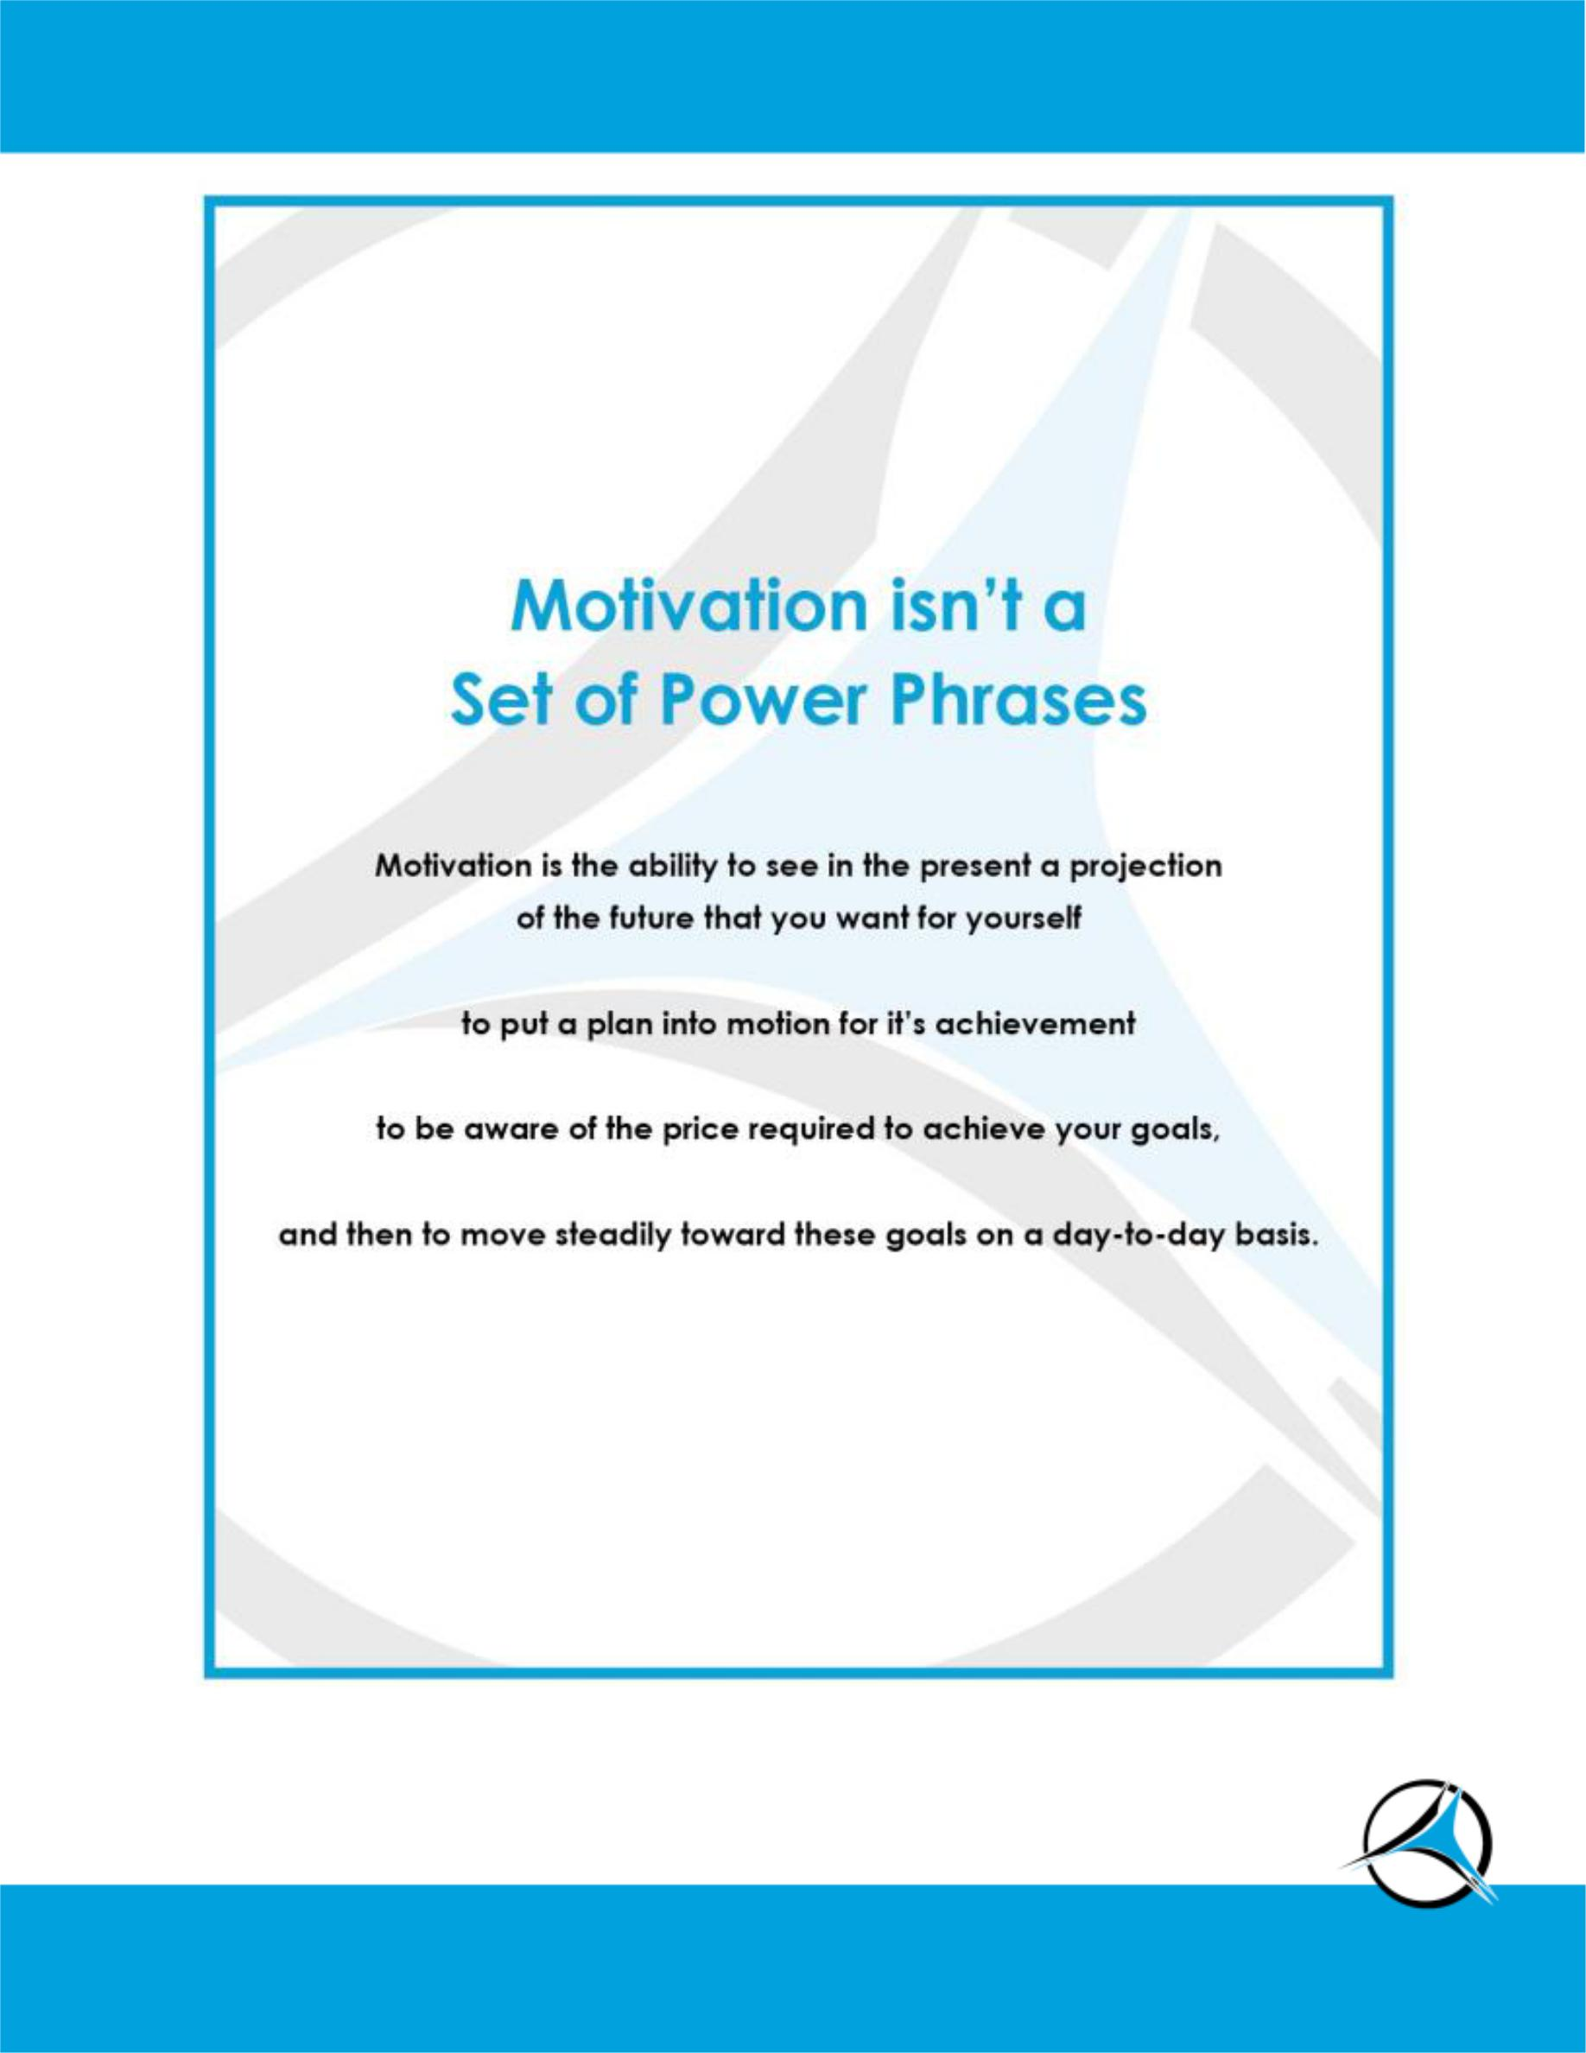

Copyright ©2015 Top Practices, LLC. All rights reserved. TopPractices.com Page 17

